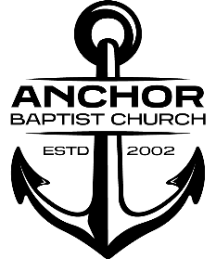

Anchor Baptist Church

Series: “First Things First”

Message: “The Church of Jesus Christ”

Scripture: Revelation Chapter 1

Date Preached: January 28, 2024

Sermon Notes

1. The main theme / message from the Book of Revelation is the Revelation of Jesus Christ
2. How will you respond?

2 Types of Responses

1.______________________

2. ______________________

3. Preview of the Risen Christ Mathew 17:1-8

1. Take Away:

Jesus loves you. His Love does not change, but neither does His judgment of our sin. If we trust Him, we will know His love, but if we reject Him, we will know His wrath.