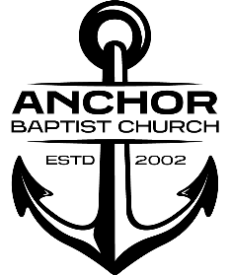

Anchor Baptist Church

Series: “First Things First”

Message: “Hold Fast”

Scripture: Revelation Chapter 2:18-29

Date Preached: March 10, 2024

Sermon Notes

1. To / Audience: ______________________________
2. From: ________________________________________________
3. Commendable Actions / Attitudes
4. Condemnable Concern(s):
5. Corrective Action:
6. The Call:
7. Take Away: ______________________________________________________________

____________________________________________________________________________

____________________________________________________________________________